Common errors to avoid when completing the SR/PNP

Below are common errors that can occur during the Student Registration/Personal Needs Profile (SR/PNP) import process, as well as solutions to correct them. This document is meant to complement the Guide to the SR/PNP Process. Contact the RICAS Service Center at ricasservicecenter@measuredprogress.org or 800-737-5103 with any questions on the SR/PNP process.

Error message | Cause | Solution
Incorrect number of tokens found on line 2, expected: 11 actual: 53 | This error message appears when selecting a User Import rather than a Student Registration Import in PearsonAccess Next (PAN).  This error message indicates that the file being imported contained more columns than expected. PAN has 53 columns in the Student Registration file. (In this example, PAN expected 11 columns for a User Import.) | The file needs to be re-imported with the correct import type (Student Registration Import).  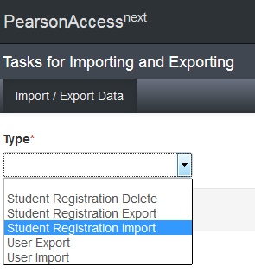
No error message, but the file is not uploaded correctly | Typically, this happens when a user imports a file that was saved in the wrong format. | Users should verify that the file is saved in the .CSV format. PAN will not import files saved as .xlsx or .txt.  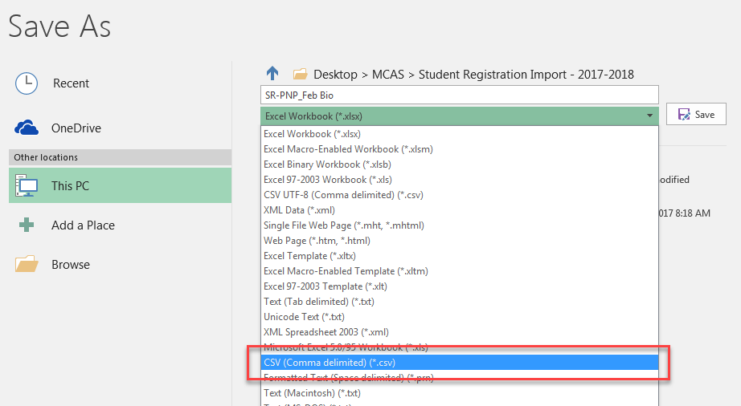
Incorrect number of tokens found on line 2, expected: 53 actual: 45 | This error message appears when using the SR/PNP file layout and field definitions from 2016–2017.  This error message indicates that the file being imported contained fewer columns than expected. PAN expects 53 columns in the 2017–2018 Student Registration file. (In this example, the file contained 45 columns.) | The file needs to be updated using the 2017–2018 Student Registration layout. Several columns were added this school year (refer to the Guide to the SR/PNP Process for details).  Once the file is prepared, it should be re-imported into PAN.
Human Read Aloud as a Non-Standard Accommodation is not valid when “testcode” is for a Mathematics test. | Several accommodations are available for only one subject area test (e.g., available for ELA but not for Mathematics). An error message will appear if an accommodation is not available for the selected test. | Refer to the Guide to the SR/PNP Process to determine if the accommodation in question is available for the subject area test that was selected.
‘___’ is not a valid test (e.g., “BIOHS is not a valid test”) | The import was not completed in the correct test administration of PearsonAccess Next, or column J of the SR/PNP import does not contain the correct test code. | Either verify that the correct test administration is selected in the dropdown menu in the top right corner of PearsonAccess Next as shown below, or refer to the Guide to the SR/PNP Process to determine that the correct test code was entered into the SR/PNP file. (Note that not all administrations are shown in the screen shot below.)  